

HAPPY NEW YEAR!

**THANK YOU**

JANUARY  
2024

01

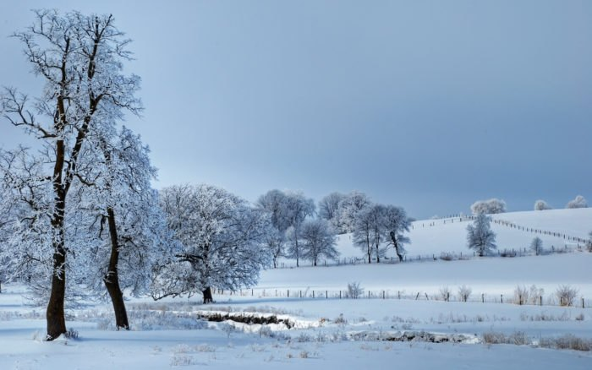

DID YOU KNOW?

**Losses to check fraud almost doubled from 2021 to 2022. The total amount lost in 2022 was $680,000!**

**We are here to help YOU! Please feel welcome to come to us with any questions if you feel uneasy or uncertain with anything regarding your finances!**

DON’T MISS OUT ON THESE GEM CLUB TRIPS!

SCOTLAND & NORTHERN IRELAND VACATION:

Includes a visit to St. Andrews!

August 8 – 19, 2024

OVER HALF FULL!

NATIONAL PARKS TRIP 2025

More details to come soon!

CANADIAN ROCKIES BY RAIL 2025

More details to come soon!

DID YOU SEE US?!

 With a putting green and trivia at the Starmont Career Fair?

 Set up at the Colesburg Trunk or Treat with a rainbow trolls trunk?

In Ed-Co schools visiting with business students about their mock business plans?

For a complimentary brat & hot dog meal at our Customer Appreciation meal in October?

**1**

EMPLOYEE SPOTLIGHT

with MIKAELA BOSS

Mikaela has been part of the Farmers Savings Bank family for almost three years, is based out of our Colesburg office, and is our Vice President of Lending. We are grateful that she agreed to sit down and answer some questions for our employee spotlight this month.

Question: What do you love about working here?

Answer: Farmers Savings Bank is owned by the Juergens family. Jolene, Tim and Jeff have instilled a family-oriented mindset within the bank, and we are one big family here. All of the employees know each other and their families. We also carry that mindset into our daily operation of business. When you walk into our lobbies, you’re greeted by name and you’re not just a number to us.

Q: Do you have a favorite service that we provide?

A: We understand that things come up last minute sometimes and in the lending department we are able to make quick, sound decisions for the customer during those times. We want to work with our customers as a team to help better serve their operation/business and their financial needs.

Q: Tell us a little bit about your hobbies/life outside the bank!

A: When I’m not working, I enjoy spending time with my two dogs, Max & Mya. I stay active by working out and playing slow-pitch softball. I also help on my family farm where we have a row crop operation, stock cow operation and raise club-calves for local 4H and FFA members.

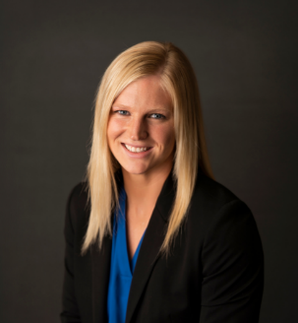

As we reflect on 2023, we are so grateful to the customers, community members and business leaders that continue to support their local Farmers Savings Bank. Small town Iowa truly is the best place to live, work, and raise our families! We love being able to support other small businesses and folks in need - it’s inspiring to see our communities lift each other up and grow stronger together. We at Farmers Savings Bank would like to say thank you for your patronage in 2023 and we’re looking forward to meeting your expectations in 2024 and beyond!

The hype is real…

ST R CHECKING

is paying

If you use internet banking and a debit card, contact your branch today and ask about making the switch!



**APY\***

**9.01%**

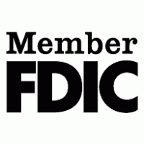

1.www.consumerfinance.gov

*STAR CHECKING:

To qualify for the STAR interest rate, each qualification cycle you must:

* Make at least fifteen (15) debit card purchases post and clear (excludes ATM transactions)
* Make at least one (1) direct deposit or automatic debit from third party that posts and clears
* Enroll in and receive e-Statements

All consumer checking accounts have a minimum opening deposit of $100.

STAR CHECKING: Daily balances up to $4,000.00 earn an interest rate of 8.66% with an Annual Percentage Yield (APY) of 9.01%. Balances $4,000.01 or greater earn an interest rate and APY of 0.32%. Must make 15 debit card purchases per statement cycle; signature or PIN based transactions qualify. Debits are determined on the date it is posted to your account and not the date of the transaction/purchase. Debit purchases at or near the end of the statement cycle may post in the next month’s statement cycle. ATM transactions do not count as debit transactions to qualify for the preferred rate. If qualiﬁcations are met, domestic ATM surcharges will be refunded up to $25.00. ATM surcharges greater than $4.99 are not automatically refunded and require presentation of a receipt. You will incur surcharges that exceed $25.00 limit or if qualiﬁcation requirements are not met. If requirements are not met, no ATM surcharges will be refunded and the account earns a base interest rate and APY of 0.05% on all balances. No minimum balance required. This is a variable rate account. For consumer deposits only.

STAR SAVINGS: Must have a STAR Checking account in order to open a STAR Savings account. Daily balances up to $20,000.00 earn an interest rate of 1.00% with an APY of 1.00%. Balances $20,000.01 or greater earn an interest rate and APY of 0.20%. Must meet requirements of STAR Checking account listed above in order to be eligible for the stated rates. If requirements are not met the account earns a base interest rate and APY of 0.05% on all balances. Limit one STAR Checking and one STAR Savings per Social Security Number. If the STAR checking account is closed within 6 months there will be a $30 early closure fee per account closed. Electronic statements (e-Statements) are free and available upon successful set up with Internet Banking. ATM refunds up to $25 per month. ATM Fees greater than $4.99 are not automatically refunded and require a receipt to be presented for a refund. ATM refunds do not include foreign currency charge.